Name : Arun Kumar

Class name : Programming with Java – ITDEV140

Date : 09/07/2014

Assignment : Assignment - 2

1)

Exercise 2-1

4) Error message when I entered the subtotal as $1000

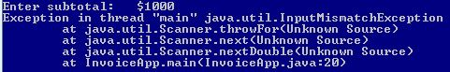

5) Entering the choice as 20 when prompted to continue

The reason for the program to terminate is that, the logic was written in such a way that, the program would terminate for any value other than ‘y’ or ‘Y’

6) Two values entered separated by whitespace

The method nextDouble() only returns the double value which is used to get the value of the variable subtotal. It does not return any whitespace. In order to return the whitespace nextLine() method of the scanner object has to be used.

2)

Exercise 2-3

Modified Invoice App

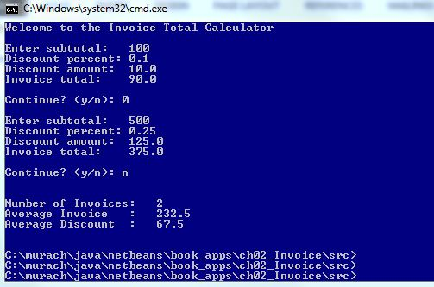

3)

Exercise 3-3

Download Time App

